Actions
- Open Remote desktop connection.
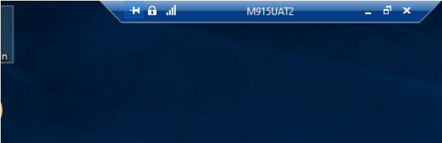
- Login to server (E.g. we are taking M903PRD1), Click on connect.
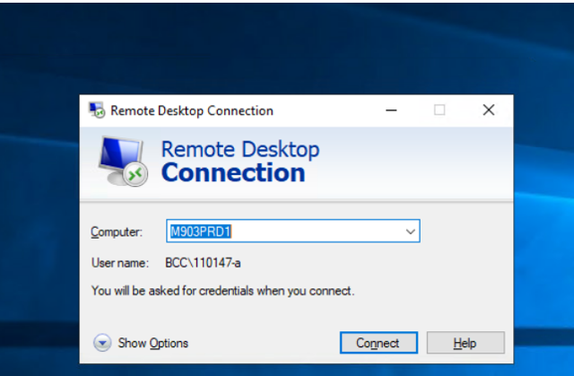
- Use a different account to connect, login using username BCC\database or BCC\XXXXX-a and then type password, Click OK.
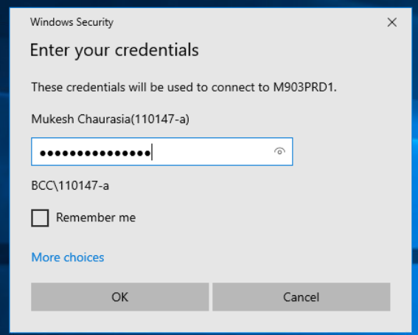
- Search "Tasks Schedule" and open.
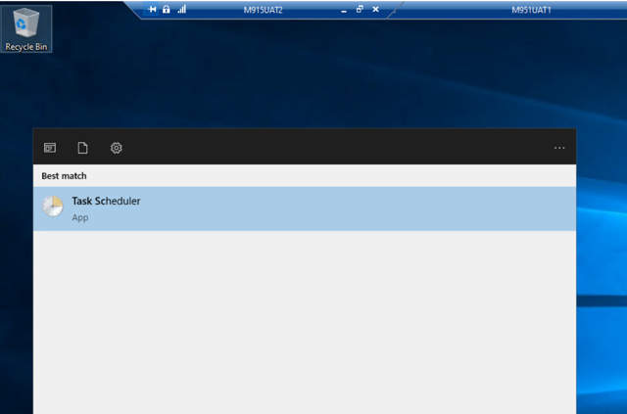
- Click on “Task Scheduler Library” in the left pane.
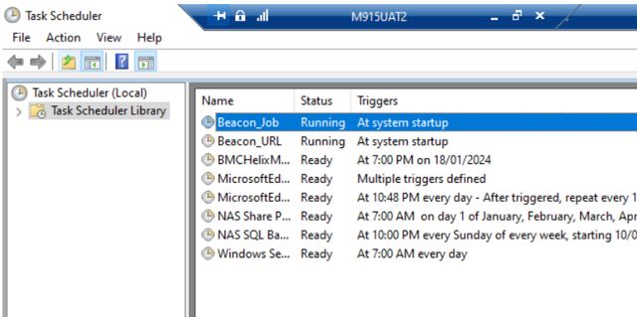
- You can show that “Beacon_start” is in running status.
- Open SSMS (SQL Server Management Studio)
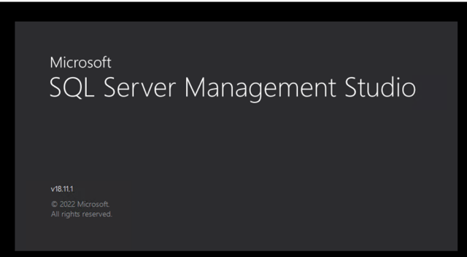
- Connect to Server with Server_Name\Instance_Name (E.g. We are taking M903PRD1 server not required to enter instance name)
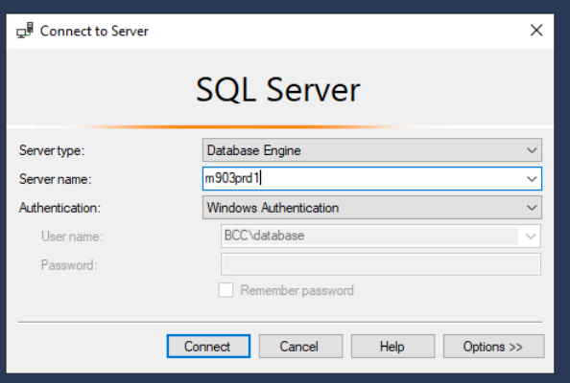
- Expend the database and click on BeaconMetrics, expend the table inside of BeaconMatrics.
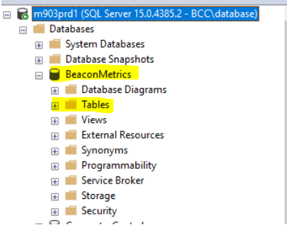
- Where given 2 table name
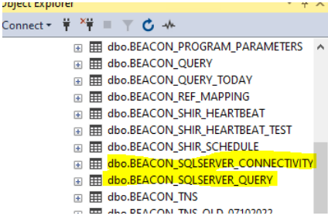
- Right click on each table and select Top 1000 row, it will show you details information about sql connection time and connection issue of the server.
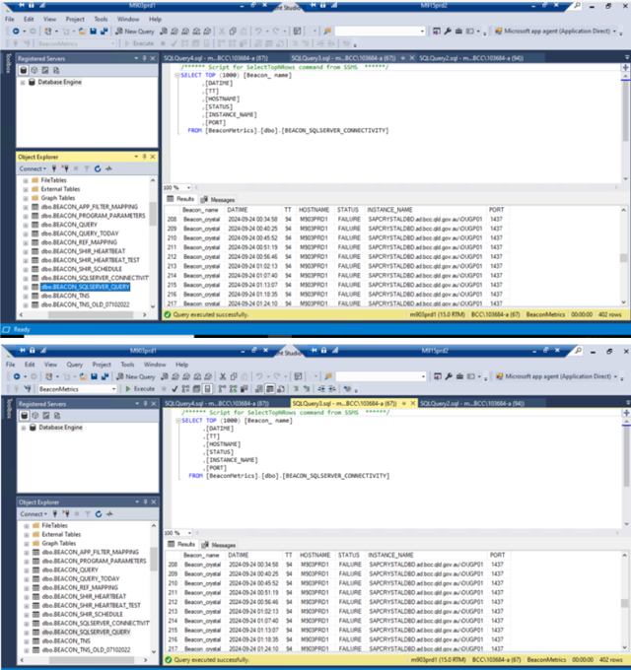
- Go to File Explorer and enter the nas address on search bar
nas-ds\DBCentral\beacon\wrk\sqlserver
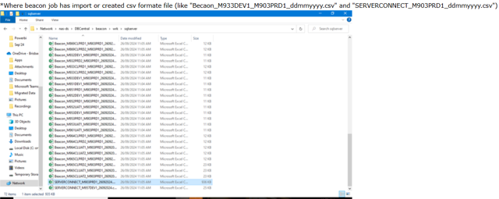
- Go to FIle Explorer, open C logical disk drive, click on app > beacon > script
